History of digital services
The digitisation of public administration services really began with the end of the millennium, when the initial legislative proposals with a national scope and enabling the subject of the law to use digitisation tools appeared. This is not to say that public administration was not digital by the end of the millennium, only that nationwide digitisation efforts with definitions of central services or uniform standards are still emerging in this period.

Before the digitisation of public administration
Prior to the nationwide digitization efforts, a legal entity could only interact with the public administration in a fragmented way, i.e. with each public authority separately, according to the agendas it performs. Each OVM kept its own file on the subjects of law that came into contact with it, and a traditional paper filing service was maintained to keep the documentation.
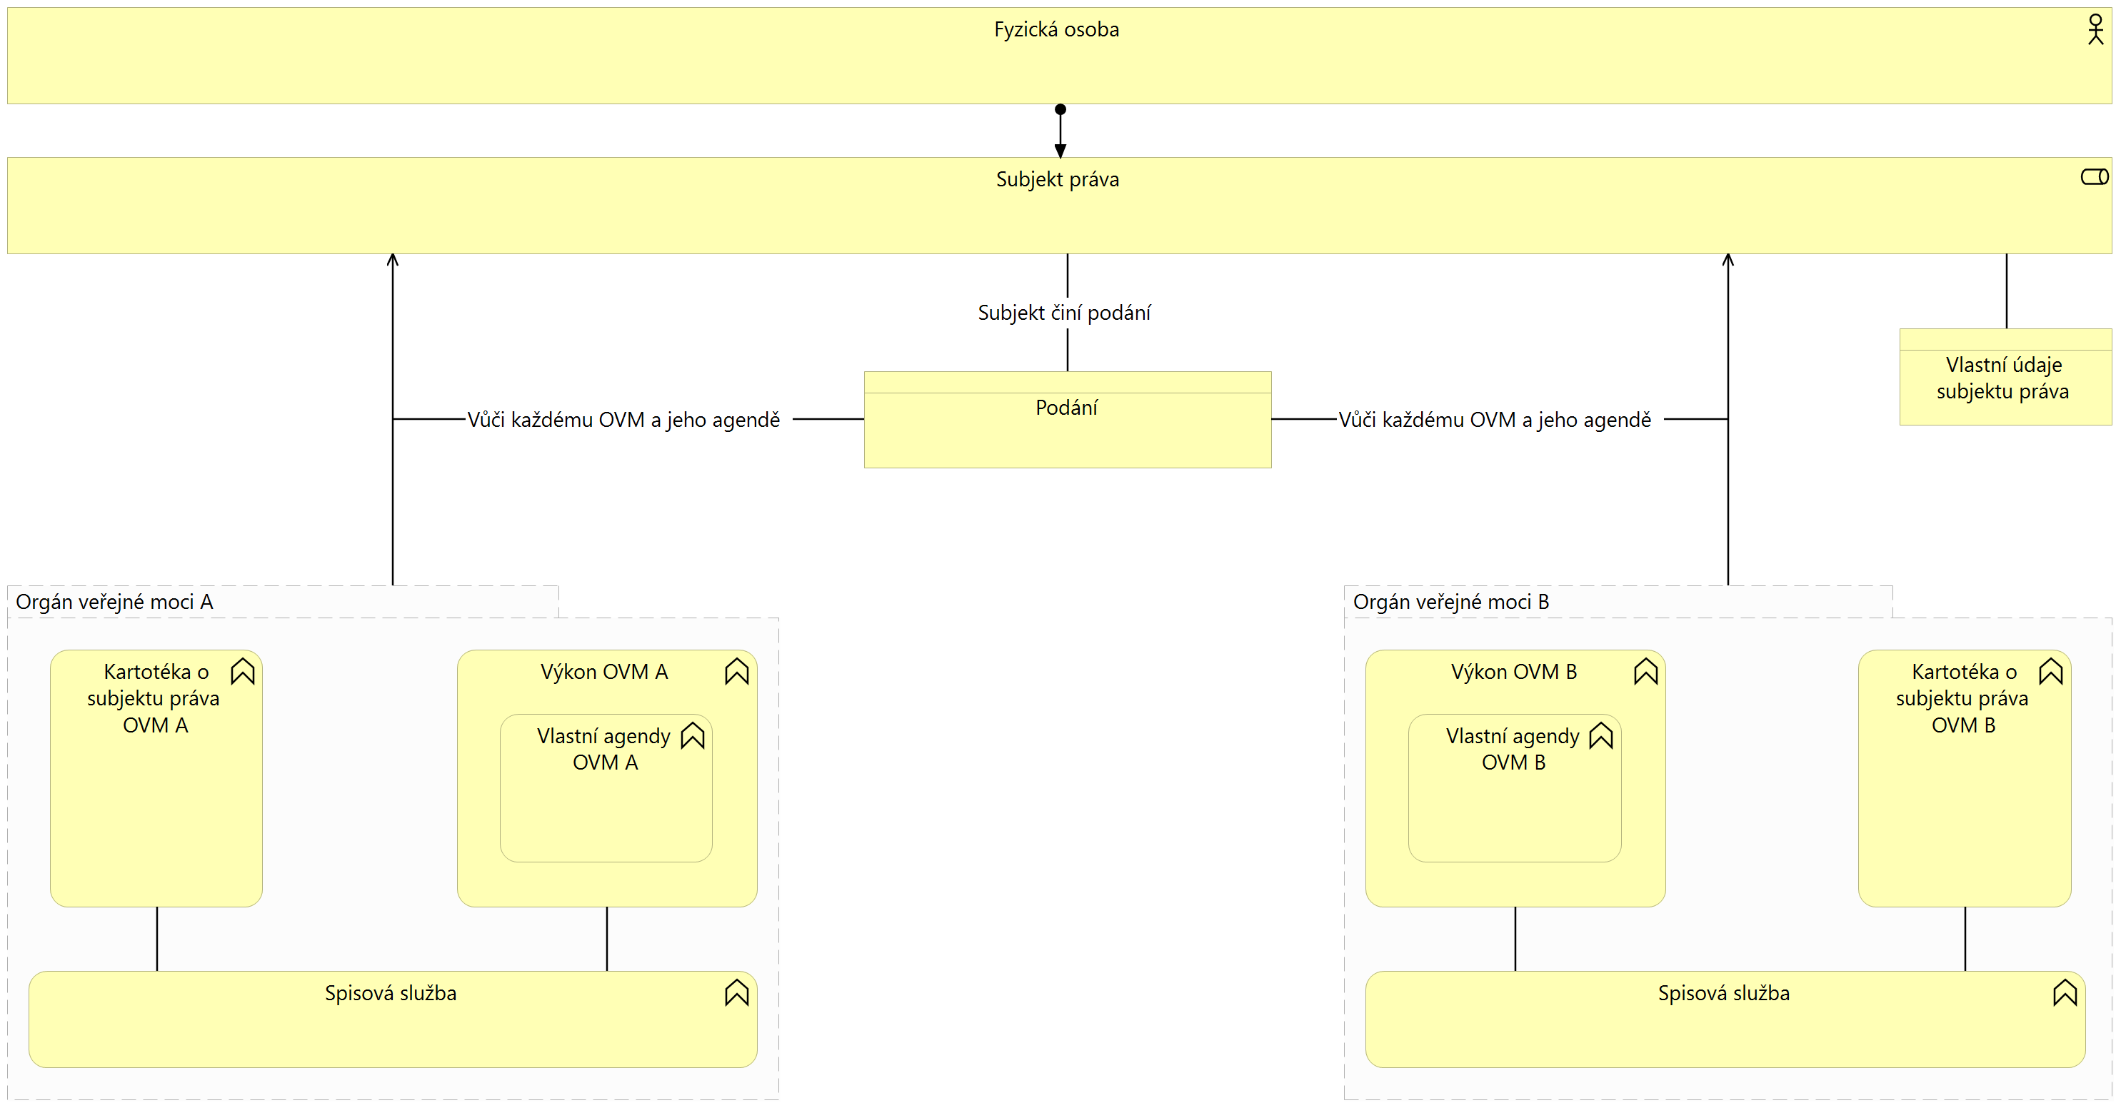

Initial digitization of public administration
The initial digitization of public administration consists of enabling filings to be signed using electronic signatures, thus doing away with the paper form of filing. Public authorities publish information on information websites where information on rights and obligations can be found. Public authorities are also working with electronic filing systems and electronic office boards. There is still no central exchange of data on the subject of law or other services for the exchange and cooperation of public administration. The public administration is divided into state administration and local government with independent and delegated competences, starting with the centralisation of public administration performance - the so-called agend.
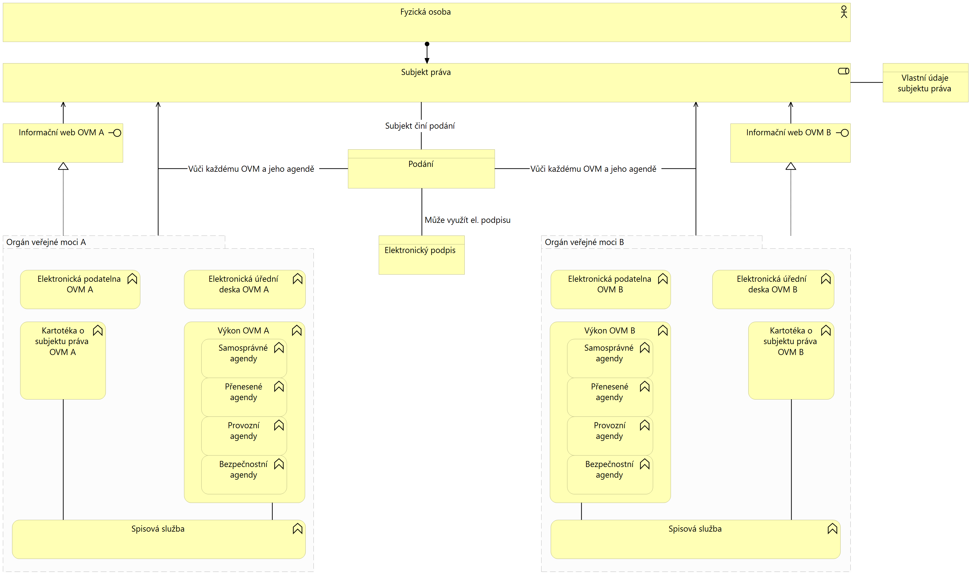

Electronic Actions and Authorized Document Conversion
An important milestone of digitization was the launch of data-box system, allowing both the taking of acts (submissions towards a public authority), delivery (exchange of documents between public authorities and communication towards a public authority) and delivery (private communications). Public authorities use the electronic filing system, but they continue to have only information web portals and are not able to exchange data on legal entities, beyond documents.
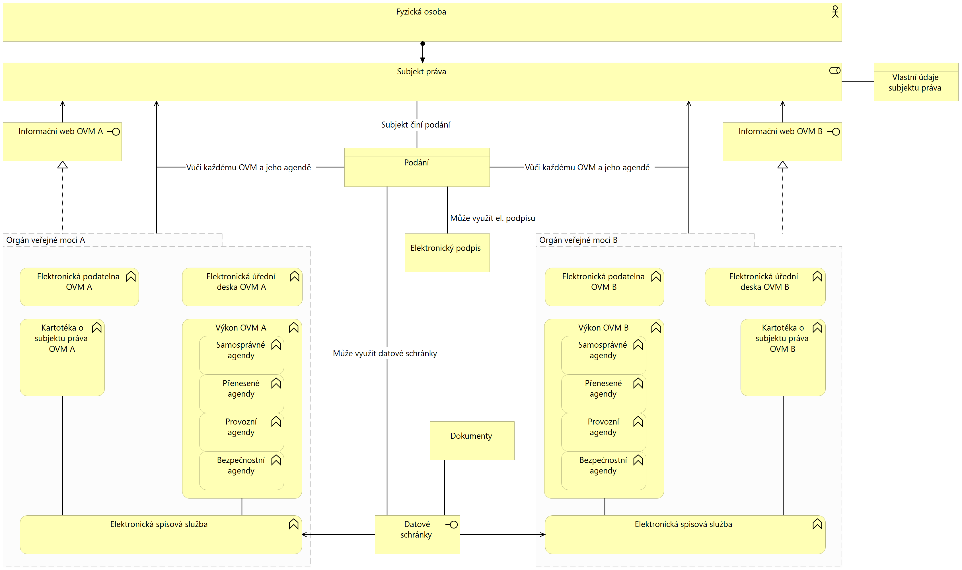

Reference Data Sharing
This milestone can be called the big bang in the sharing of rights holder data. A central service for sharing so-called reference data, i.e. data that is always correct, up-to-date and guaranteed by the state, has been launched. Public authorities become providers of agenda services, which can be provided by individual public authorities or centrally on behalf of several public authorities. The sharing of reference data is governed by agenda laws, determining, among other things, the executor and the notifier of the agenda, but also the authorisation to access the reference data. The data subject is free to use the public administration contact point and is not obliged to inform the public administration authorities of changes to reference data. However, the front-end problem persists, where portals are information-only and the data subject is forced to interact with agendas through a limited set of electronic channels.
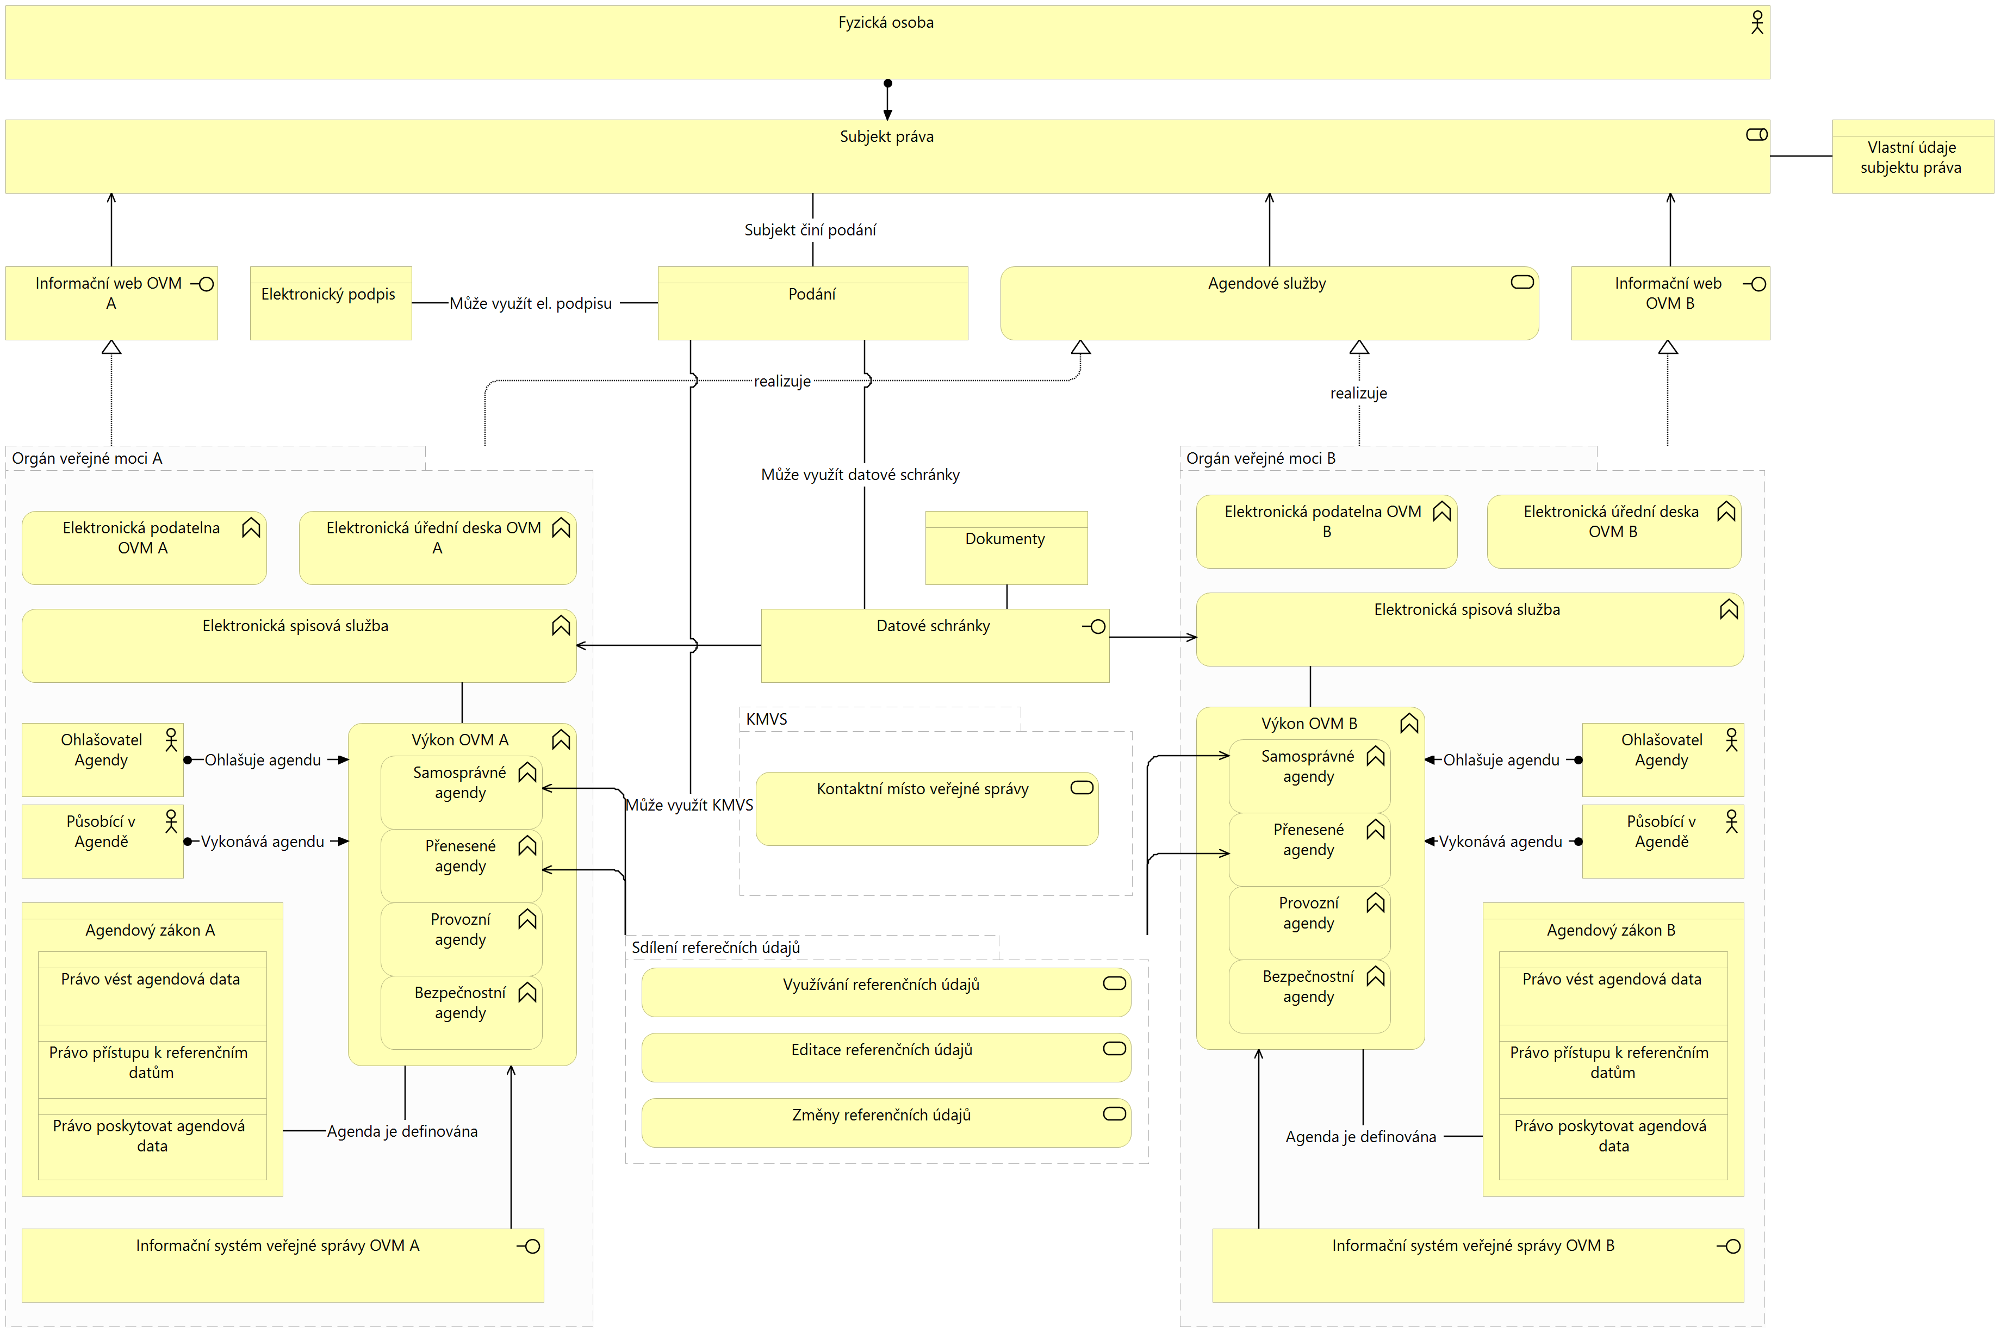

interconnected data pool and Front-End Standardization
The current top milestone is the launch of the interconnected data pool, which differs from the previous reference data sharing mainly by offering to share also agency-specific data about the legal entity. This has the consequence that once data about a right holder appears in the public administration in one agenda, no other agenda should require it on the right holder. In addition to non-public data about the rights holder, public data is also shared, and this is done via the interconnected data pool. The rules of these pools are similar.
The subject of the right is given the possibility of electronic identification to individual transactional portals, which are federated into a central citizen's portal. With electronic identification, it opens up the possibility to use the agenda services directly via self-service, thus it is a completion of the original front-end and direct use data exchange services between public authorities.
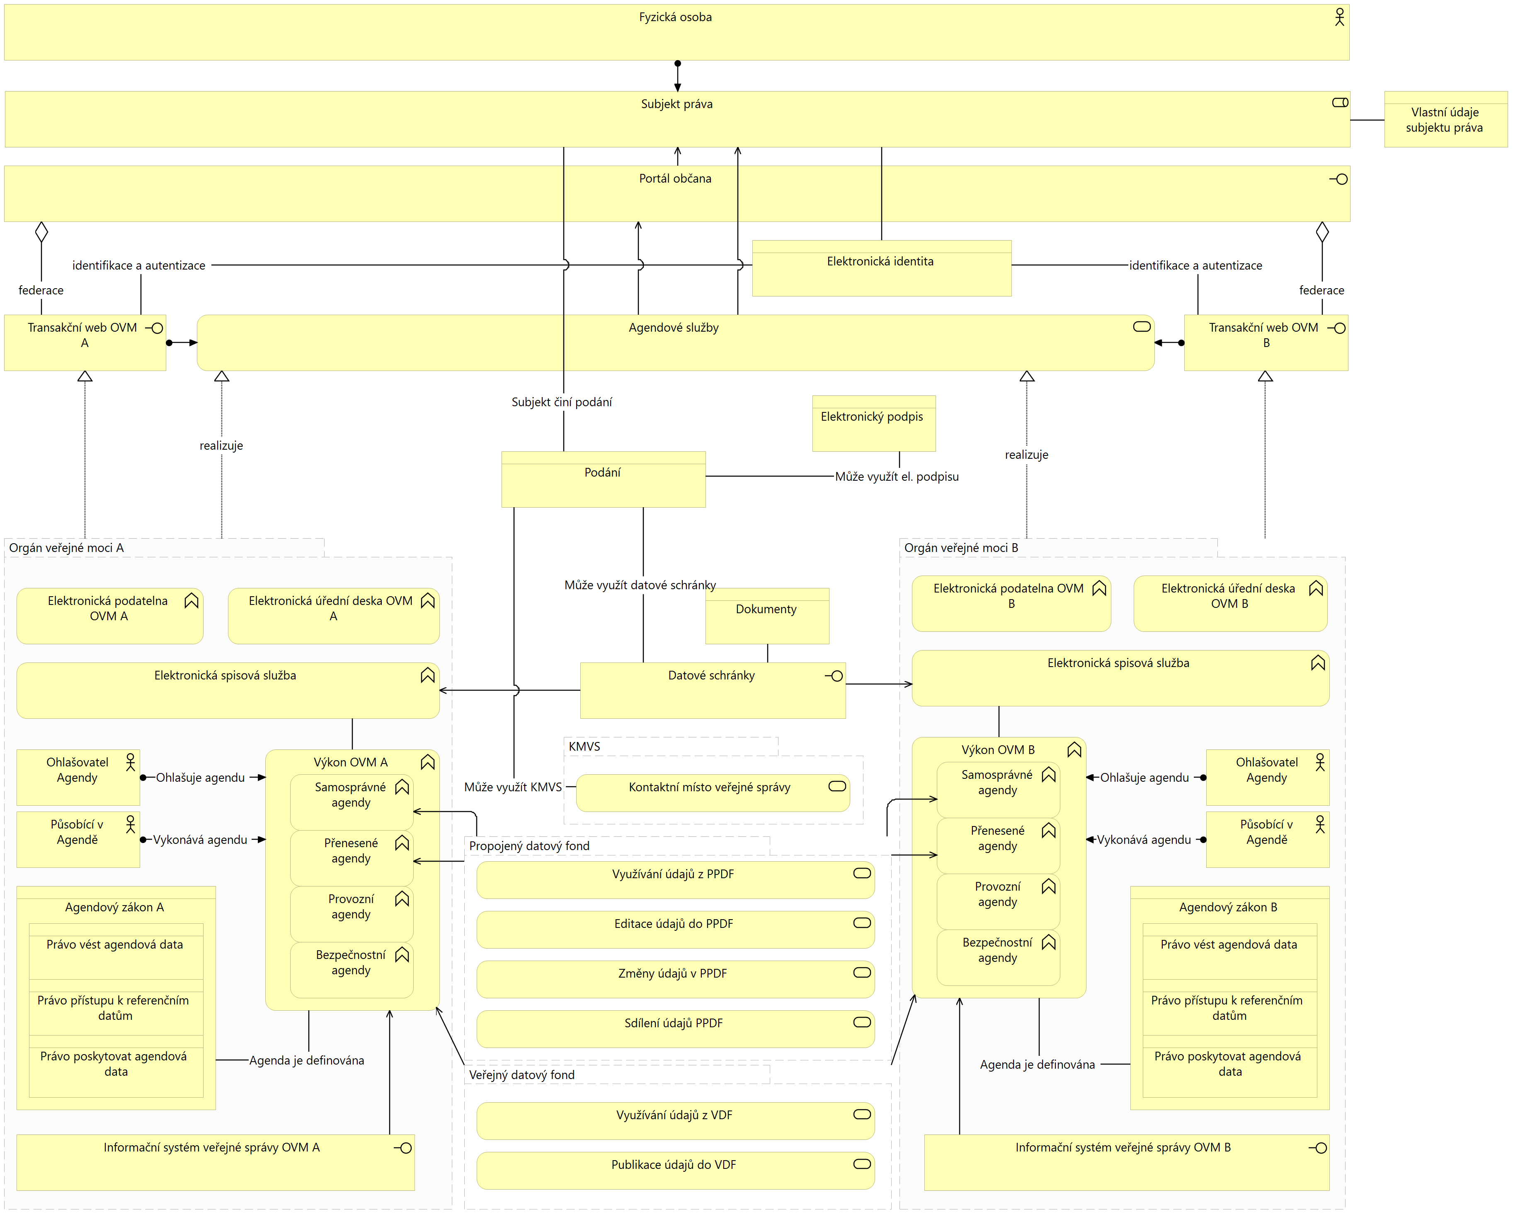

Implications for the digitisation of services
The preceding chapters show that the development of digital eGovernment services of the Czech public administration is mainly enabled by the provision of central shared services that can be used by public authorities. Therefore, with each new central shared service there is a shift in the digitisation of the whole Czech public administration, which must be supported primarily by 2 aspects:
- A digitally friendly legislative environment. For the next period, the Act and Legislative Regulation of Legislation known as DEPO2 (Parliamentary Print 756) is assumed as the legislative environment for digitisation.
- Demand from clients. Here, digital services must not only be created and offered, but actively promoted and advertised to end clients in a non-violent way explaining their benefits.
The following central shared services are available to public authorities to meet the needs of digitising public administration services:
- Front-end
  - Citizen's portal and a federation of portals consisting of a unified Design system gov cz appearance and a unified Service catalogue structure.
  - Uniform identification and authentication of the client using the National Identity Authority.
- Back-end
  - Integration to interconnected data pool using eGON services Basic Registry Information System and Shared Service Information System.
  - Use of Data Box Information System for the exchange of documents between public authorities and in communication with the client.
  - Allowing submissions against own agenda within the Contact point of public administration.
  - Integration to Uniform Identity Space to provide a single authorization of an individual to the role of an official.
Use of the Public Administration Communication Infrastructure and the Central Service Point for secure network communication between public authorities and publication of public services to the public Internet.

