Connecting Metropolitan Networks to CMS
The following describes the variants and method of connecting Metropolitan Networks (MAN) to Central Point of Service (CMS) via Regional Networks, Territorial Departments of the Police of the Czech Republic, Academic Network CESNET or Financial Offices (GFD network).

Definition of Metropolitan Area Network (MAN)
The Metropolitan Area Network is the city's optical communications backbone - a high-capacity, high-speed communications infrastructure. The primary purpose of this network is to connect the City's public offices, educational facilities, hospital facilities, fire department, cultural and social facilities, and other entities established by the City. One of the services provided by the Metropolitan Networks of the Future is the connection to CMS/KIVS.
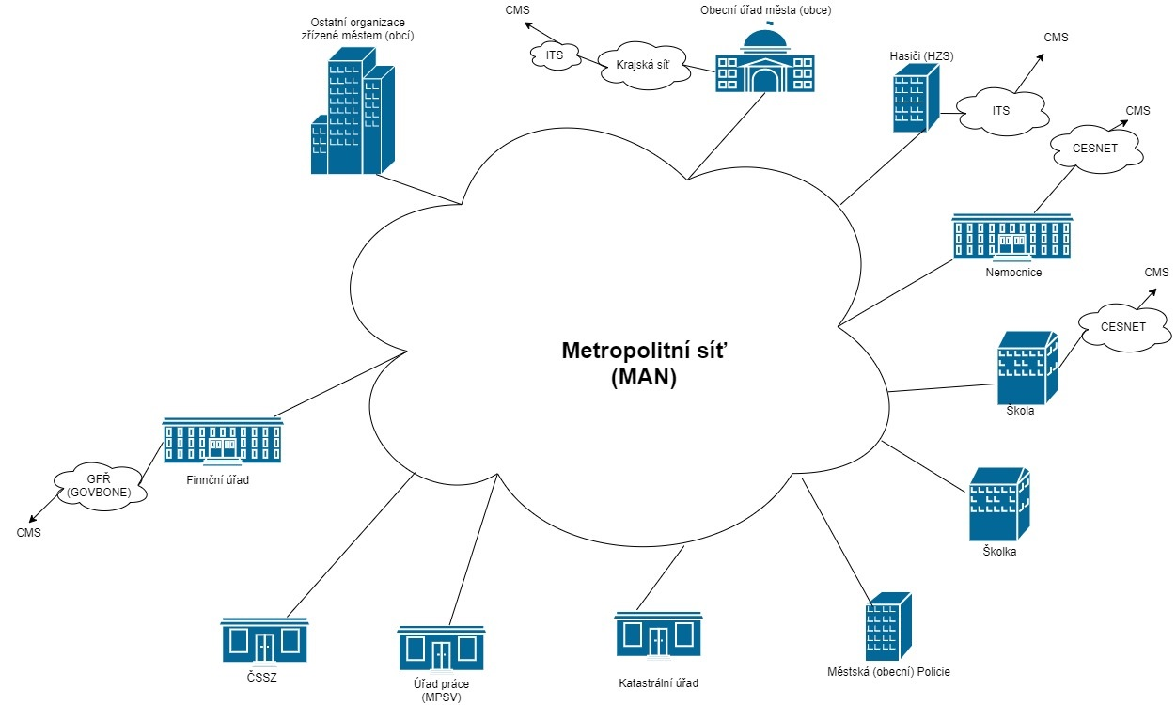Example of a metropolitan network and connectivity options

Description of how to connect the Metropolitan Network to the CMS

Connecting the Metropolitan Network through the Regional Network
A condition for connecting MAN via the regional network is a functional optical link between MAN and the regional network, see Figure 2.
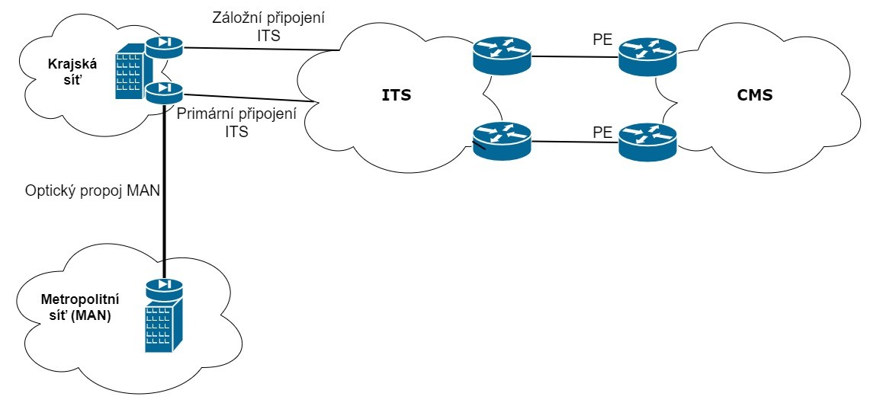Example of connection of the Metropolitan Network via the Regional Network

Connection of the Metropolitan Network via the Territorial Department of the Police of the Czech Republic
A condition for connecting MAN via the Territorial Police Department is a functional optical link between MAN and the Territorial Police Department, see Figure 3.
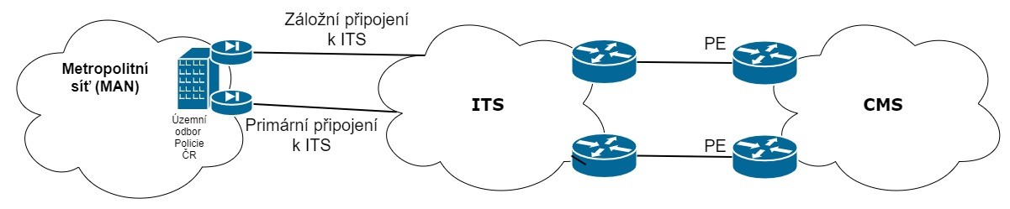Example of Metropolitan Network connection via the Territorial Police Department of the Czech Republic

Connecting the Metropolitan Network through the Academic Network CESNET
The condition for connecting MAN via the CESNET Academic Network is membership in the CESNET Interest Group and having a functional optical link between MAN and the CESNET Academic Network, see Figure 4.
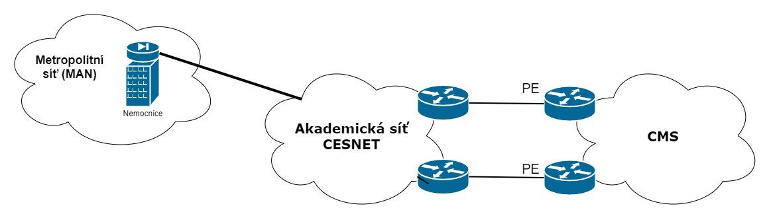Example of a Metropolitan Area Network connection via the CESNET Academic Network

Connecting the Metropolitan Network through the GFD network
A condition for connecting MAN via the GFD network is a functional optical link between MAN and the GFD network, see Figure 5.
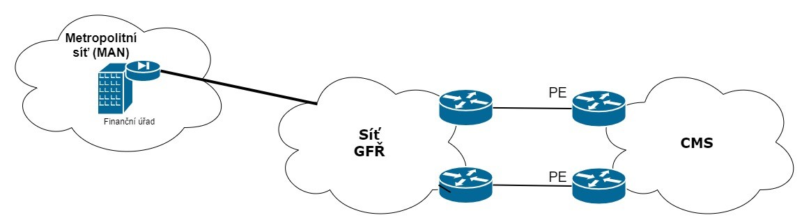Example of connection of the Metropolitan Network via the GFD network

